 | 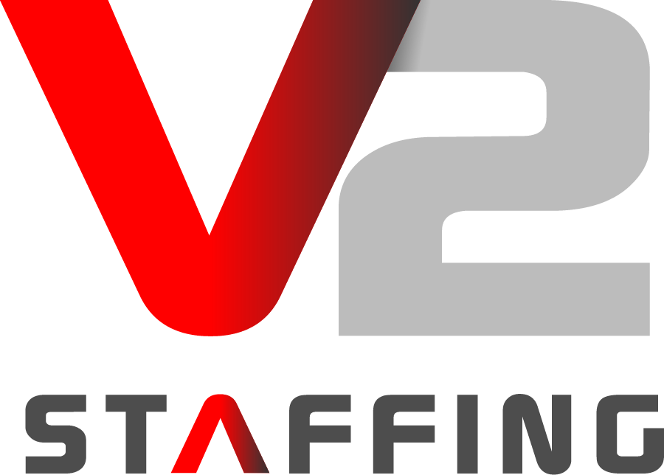
Company Info  10320 Little Patuxent Pkwy  Suite 200  Columbia, MD 21044  (443) 545-3773  info@v2staffing.agency |  | Description  V2 Staffing is a staffing agency specializing in placing TOP healthcare professionals on permanent, part-time and as needed contracts with federal agencies but commercial businesses. Our abilities to deploy our national resources and effectively handle contract surge requirements have made V2 Staffing a leader in government and commercial staffing support.
Currently Seeking  Registered Nurse  DC metropolitan area |  | Job Description  V2 Staffing is currently seeking an RN for potential placement opportunities in the DC metropolitan area. We are looking for a compassionate, reliable, credible professional who is knowledgeable and well trained in the nursing scope of practice. The individual will be able to follow health and safety guidelines faithfully and consistently. As an available agent at V2 Staffing you pick your hours, you decide what type of patients you see and what services your willing to provide. As an available agent at V2 Staffing, we offer options to meet the needs of our employees and our clients!
Key Skills |  | Job Qualifications  - Bachelor of Science degree in Nursing (BSN); An active, current registration  - as a professional nurse in a State, District of Columbia, the Commonwealth  of Puerto Rico, or a territory of the United States.  - Minimum of five years of verifiable experience as a licensed Registered  Nurse  - Minimum of three years of verifiable work experience as a licensed  - Registered Nurse working in a residential treatment, community corrections,  re-entry, or correctional facility; public health clinic, or federally  qualified health center
Our Commitment |  | What to expect from us!  After completing an initial phone screening, we will determine what positions we believe you will be best suited for. We will directly apply for you and instead of just attaching your resume we will be your direct advocate for that position. When new opportunities present, you will receive notice of new potential assignments.  Why sit on job posting websites like indeed and monster for hours individually filling out applications. Let us take over that hassle for you by putting you in direct contact with our large network of medical facilities in dire need of medical staff members!  With V2 Staffing, we are your advocate, your placement officer and your employer. We go above and beyond to make sure our staff receive competitive pay. We offer a full benefit package and run full background checks completely paid for by us. Our pay is semi-monthly, and we offer referral bonuses for new staff along with new employers seeking staff members. Please give us a call at (443) 545-3773 for more information on our referral program.
Your Promise |  | What we expect from you!  - RN License  - CPR/BLS Certification  - Willingness to undergo a Background Check  - Must possess knowledge of methods, techniques, and procedures to perform job activities on various types of medical equipment and automated systems and of safety principles and infection control in the patient care environment.  - Excellent verbal and written communication skills  - Able to maintain a professional demeanor and interface with high level medical providers, clients  - Superb customer service  - Detail-oriented and organized  - Reliable, dependable, and trustworthy, as well as able to maintain confidential information  - Able to work designated schedule, as well as maintain attendance and punctuality-

